Project Report
Amin Majdi
Introduction:
Recent development in technology paved the way for many new devices to pop up in the market. A considerable part of these devices uses sound as one of their communication ways. People with hearing problems are always excluded from the users of most of these devices. Video door-phone is one of these devices which works with "ringing". In this task, we will help people with hearing problems to answer the door with the help of the "stretch" robot.
We will simulate all the processes in this project using the Gazebo simulation. All the communications between the robot, doorbell and the person with a hearing problem will happen using ROS.
The robot receives a massage that somebody is at the door and departs to see who is at the door. The robot's database contains all the known people who are allowed to come in without permission. Suppose the person at the door is known to the robot. In that case, the robot will open the door and go back to the owner to let him know that somebody is coming in. if the person at the door is unknown, the robot asks the person to hold on and goes to the owner to let him know that an unknown person is at the door. If the owner gives permission, the robot will go and open the door. Otherwise, the robot will go to its home position.
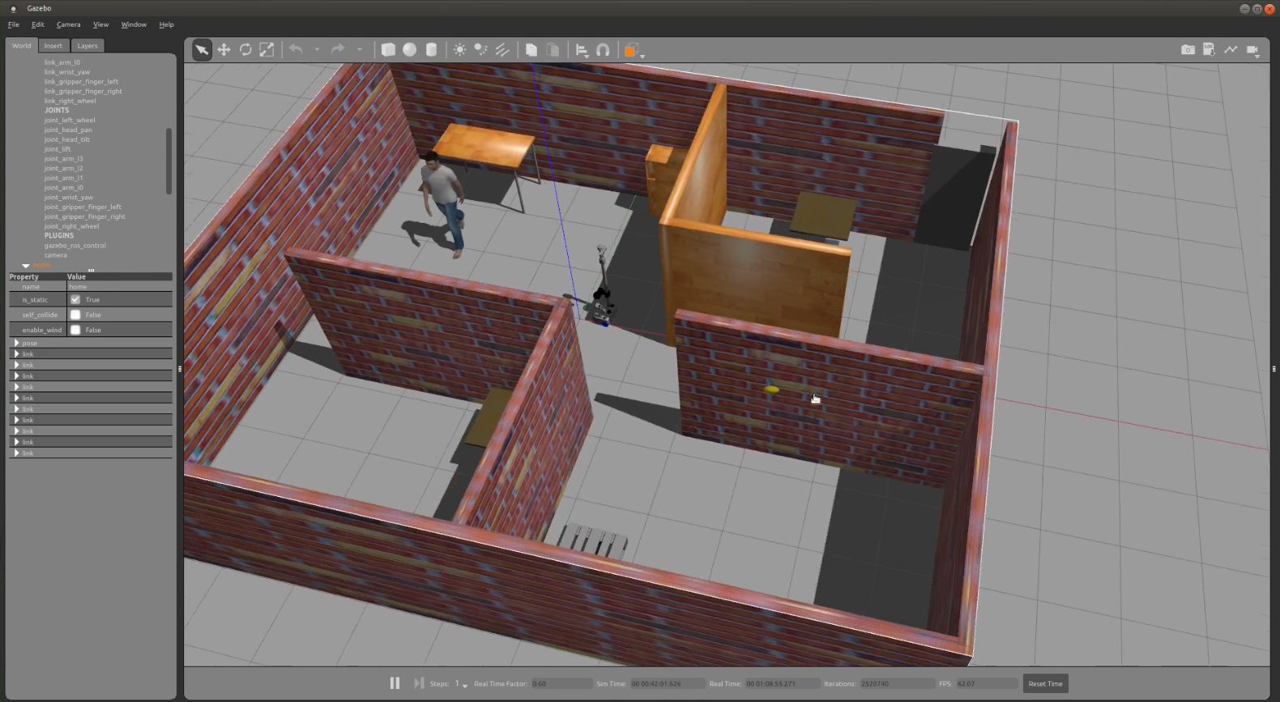
Fig 1. Gazebo environment
The Stretch robot is a mobile robot that provides us with all the features we need in this project, like moving in the apartment, pulling, pushing, and notifying the owner. It is Gazebo-friendly, and all the required files for simulating the robot in the Gazebo environment are available(fig.1). The robot has small wheels to move in the apartment and has an efficient gripper to help us open the door.
The following chart shows how the robot will react to the person at the door.
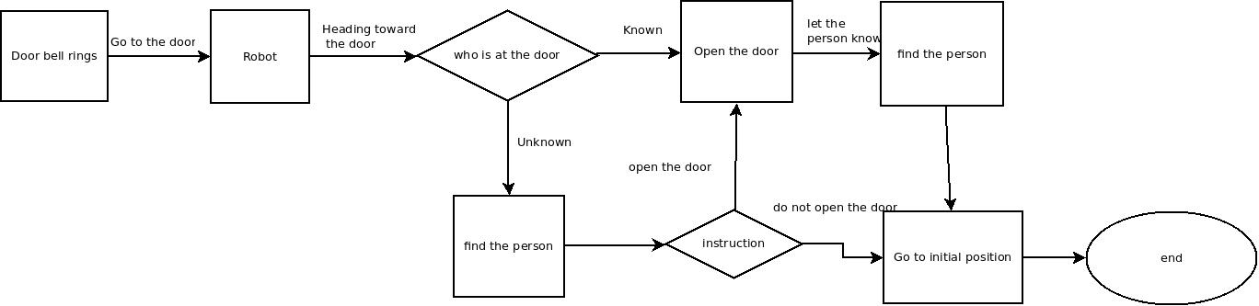
Fig.2 Task flowchart
Flowchart decomposition:
Doorbell rings:
The doorbell will communicate with the robot through a Ros topic in this stage. After receiving the message from the doorbell, the robot departs to the door to get some information.
The robot goes to the door-phone
In this task, the robot knows precisely the map of the apartment and the location at which it is. This is a perception task as the robot needs to monitor all the objects around and move toward the door. The robot will do this task using depth cameras, which can help it know its location with respect to all objects around.
Recognizing the person at the door
In reality, the robot will do that using computer vision. It will analyze the door-phone screen to recognize the person at the door and find whether it knows the person or not, using its database. In this project, as the robot reaches the door, it will request a service. The ROS service will provide information about the person at the door.

Find the person
This task is also a computer vision mission. The robot needs to go to all the rooms and search for the person using its cameras. After finding the person, the robot will go near the person (Ideally stops at 1 meter distance), and the person will see the instruction on the robot's screen. If the robot asks the person about opening the door, in reality, the person can touch the screen to select the commend. The robot either goes to open the door or goes to its home position based on the command. All the communications between the robot and the person in this project will happen through ROS topics.
Opening the door
When the robot is at the door, it can approach the handle and use its gripper to open the door. To do so, the robot needs to see the door handle using its cameras. In this project, this step also happens through ROS topics.
Go to the initial position
The robot knows about its location at the moment. So this ask is the same as going to the door. The robot will find its way to go to its initial position.

Background:
In the past decades, researchers have been interested in assistive robots to reduce the dependency of people with disabilities and ease the caregiver's job. One area that has captured a lot of attention is assistive robots at home. There are many daily tasks that people with different disabilities are dependent on, and they are desperately looking for a robot to help them do these tasks. Answering the door is one of these tasks which people with hearing problems always need to be covered by assistive robots. In this regard, K. L. Koay et al. [1] investigated the behavior of assistive dogs and tried to imitate the dog behavior using eye gaze and convince the participant to follow it. Their final results indicate that untrained participants could correctly interpret the robot's intentions.
Matthias Mielkeet al. [2] provided a smartwatch for people with hearing disabilities to recognize the doorbell and the phone rings. It uses pattern recognition technology to differentiate between different sounds in the environment. It can show the sound source on the watch screen and vibrate whenever the doorbell or phone rings. Although this device is handy, It does not provide any information about the person at the door.
Pushpanjali Kumary et al. [3] also developed a stand-alone device to answer the door for people with a hearing problem. The system has a camera at the door, captures visitors' picture, and sends it to wireless GCM and Bluetooth to the person with a hearing problem. There is also a variable device for the person with a disability that whenever somebody rings the bell, the device starts to vibrate. Although it is a cost-effective device, it can only answer the door, and paying too much just for answering the door is not a good idea. Also, some people may not want to wear a wearable device just to answer the door. In our project, we assume that the person with a disability has already purchased a multi-purpose mobile robot, and what we are proposing is an add-on to this robot.

User Interface:
In this experiment, we assume that the robot has a screen that can communicate with human subjects. We used the Tkinter module in python to create the UI. In the first scenario, the robot can capture the picture of the visitor at the dor and show it to the participants to get the instruction. In the second scenario, we will notify the participant using the text. We only needed two bottoms on the UI in the current research. Open the Door and Do nothing bottom. Later, we can add different modules to this UI depending on the situation. In the long term, having a known people database needs to be added to this UI. Also, we can add different modes like “Do not disturb”, which tells the robot to ignore the doorbell at the moment, “party mode” , in which the robot will open the door no matter who is at the door, etc.
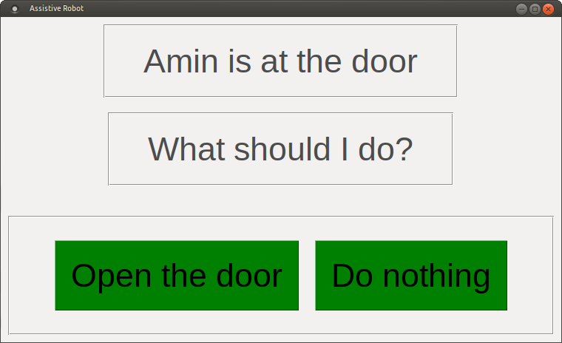
Fig 3. The robot screen in the second scenario
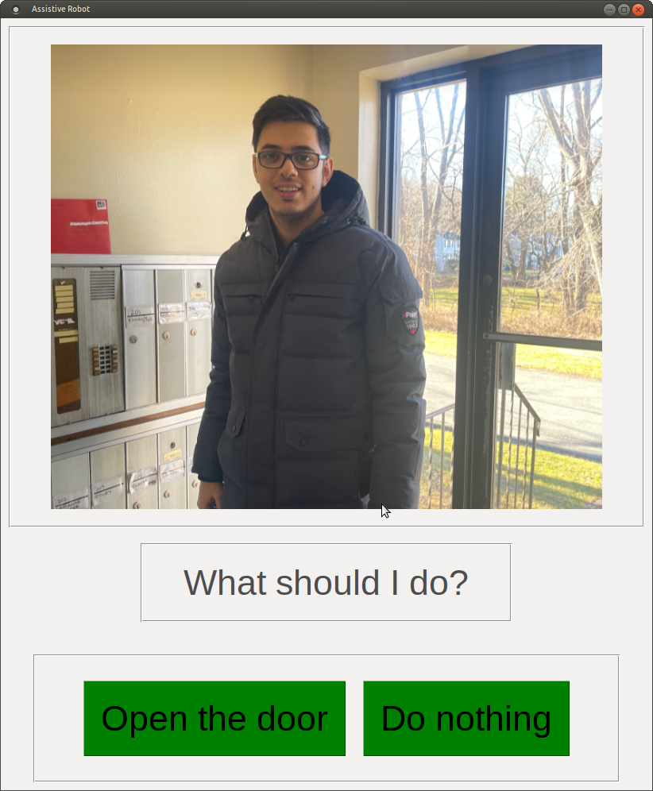
Fig 4. The robot screen for the first scenario
In both scenarios, the person can choose “open the door” or “Do nothing” bottom. The bottoms will activate the robot to go to the door or go to its home position respectively.
Experiment Design and Procedure:
In this experiment, as I am working with a simulated version of the robot and I do not possess a robot in the real world, I will work with videos of the robot performing a task. I will manipulate some performance-related features of the robot and study the effects of those on human-robot interaction.
The robot that I am going to use for this experiment is the stretch robot. It is aimed to assist people with hearing disabilities. As a human with a hearing disability cannot hear the doorbell, the robot is aimed to open the door or take some information from people behind the door and inform the human user about that.
Experiment Design
In this experiment, I will manipulate the robot's method for conveying information to a human user. I consider having two robots with similar appearances and different performances. There is only one main difference between these two robots' performance. The first robot interaction with the human is a text-based method. The robot has a screen on it, and humans can see some written information on the screen. The second robot also has a screen; however, rather than showing written information to the human, the robot shows a video to the human user.
I will make two videos of the two robots doing the same task in this experiment. The doorbell rings, and the robot goes to the door to see who is there and provides humans with information about the person in the back of the door. The first robot returns with some written information on the screen. The human can read the information and tell the robot what it should do next. The second robot returns with videos of the person in the back of the door and shows the video to humans.
Experiment Procedure
- Recruiting participants from MTurk
- Asking participants to read and sign a consent form
- Asking participants to read a scenario:
- Imagine you are a person with a hearing disability. Imagine having a robot helping you take doorbells tasks in your everyday life. The robot can build a database about your belongings and know people by the passage of time.
- Then I will tell people that in the next step, you will be shown two robots, and you have the option to choose your assistant between those two robots.
- Next, I ask people to watch two videos from the first and second robots performing the same task.
- After watching videos, I ask people to select one of the robots as their assistant for taking the doorbells and mention the reason behind their choice.
- Then I assign half of the participants to have the first robot as their assistant and another half to have the second robot as their assistant.
- At the end, I ask them to fill a questionnaire about how they like and how they evaluate the robot that they are assigned to have as their assistant.

Research Question and hypothesis
Q: Whether people with hearing disabilities would rather the information by the assistive robot be presented to them in a written or visual format (i.e., video)?
H: I believe the people would like video-based information presentation by the robot better for multiple reasons. First, it is easier to get the information from the video, and videos are sometimes more informative than written data. Second, some people with hearing disabilities might not have been literate to read the written information.

Q1: is it an exploratory or a confirmatory experiment?
It is both exploratory and confirmatory. It is exploratory as I have not seen any similar studies, and this experiment is not built over another experiment by any other research group. In addition to that, as I ask participants to choose between the two robots and mention some reasons for their choice, I expect the results of this experiment to detect some hidden facts, advantages, and disadvantages about each of these two robots and how they convey information.
It is confirmatory as I have a hypothesis, and I have some reasons for my hypothesis, and I expect the results of this experiment to confirm my hypothesis.

Q2: Are the methods used in this experiment qualitative, quantitative, or mixed? And what type of metrics will be used in this experiment?
I am going to use a mixed-method in this experiment. I have a step in this experiment in which I ask participants to choose their preferred assistant among the two available robots and mention their reason for their choice. These reasons mentioned by people are qualitative. However, I also have a questionnaire at the end of the experiment, which provides quantitative results.
All the measures that I will use in this study are subjective, as they are all reported by humans, and there are no measures based on human behaviors or errors, etc.

Q3: Is it a between-subject study or a within-subject study?
It is a between-subject study. Although all participants see both videos, half are assigned to fill the questionnaire for robot one, and the other half fill the questionnaire for robot two.

Future Works:
What we did in this experiment is just a tiny part of the work that we can do. For future studies, we can have a very efficient UI. It can have a setting tab with modes, screen colors, light configuration, speed setting, and database. The robot can have many modes, and each mode can be evaluated separately. Screen color, lights, and other appearance features are areas we could focus on. We also can evaluate the height of the robot hand and the screen size and height. In addition, the overall safety can be measured using factors like the robot's speed, how close it can get, etc. Finally, we can measure the level of trust in participants by creating faulty situations for the robot and seeing how a robot can retain human trust.

References:
[1] Koay, K.L., Lakatos, G., Syrdal, D.S., Gácsi, M., Bereczky, B., Dautenhahn, K., Miklósi, A. and Walters, M.L., 2013, April. Hey! There is someone at your door. A hearing robot using visual communication signals of hearing dogs to communicate intent. In 2013 IEEE symposium on artificial life (ALife) (pp. 90-97). IEEE.
[2] Mielke, M. and Brück, R., 2016, August. AUDIS wear: A smartwatch based assistive device for ubiquitous awareness of environmental sounds. In 2016 38th Annual International Conference of the IEEE Engineering in Medicine and Biology Society (EMBC) (pp. 5343-5347). IEEE.
[3] Kumari, P., Goel, P. and Reddy, S.R.N., 2015, September. PiCam: IoT based wireless alert system for deaf and hard of hearing. In 2015 International Conference on Advanced Computing and Communications (ADCOM) (pp. 39-44). IEEE.

